Project proposal:

* Track & topic selected:
  + Music Genre and Band Touring Analysis
    - Data Engineering: Ben
    - Data Visualization: Amanda and David
* Datasets selected: Ticketmaster API (5000 API calls a day)
* Screenshots/sketch of planned dashboard (visualization track only)
  + <https://docs.mapbox.com/help/demos/show-changes-over-time/step-three.html>
  + A map of a city

    Description automatically generated
  + Heat map, venue location or genres
  + 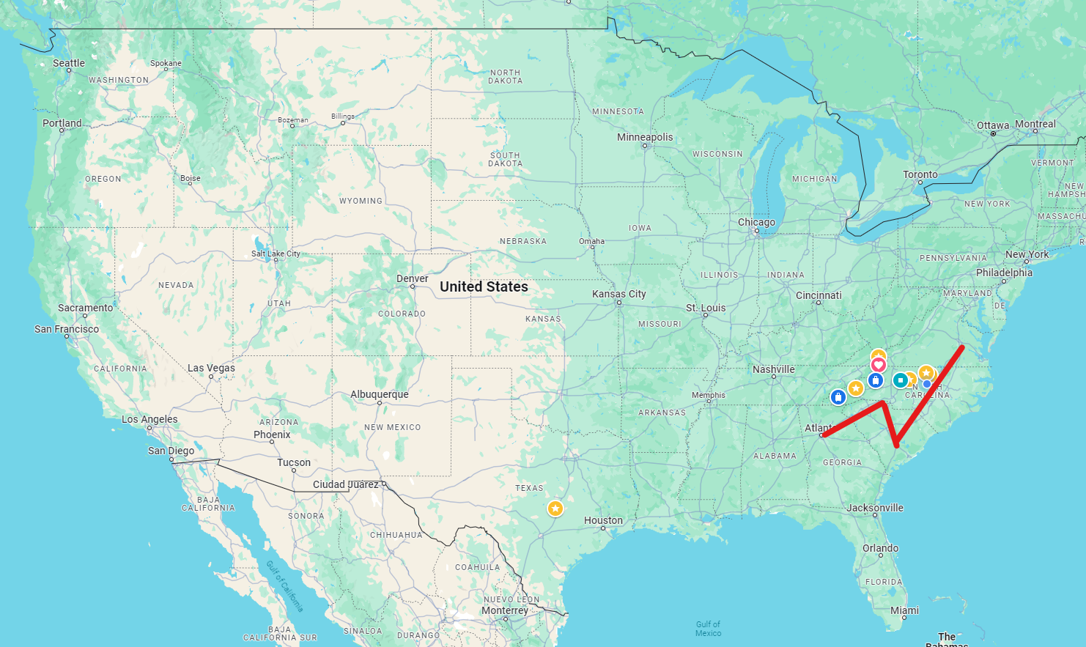
  + band tour route
  + Time series chart of band sales, subject to change (possibly bar chart race)
  + 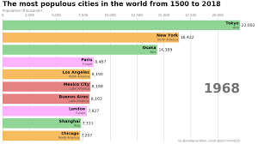
* Bullet point list of goal design/output for the project
  + Figure out connection to ticketmaster api
  + Pull and analyze available data
  + Clean data
    - Standardize locations
  + Filter data for appropriate time range
  + Determine data storage SQL, MongoDB, SQLite
  + Build out visualizations
  + Test
* This can eventually be used to start separating out tasks for your team
* Project repository created and pinned in your team's channel
* Start out with some basic data cleaning to get the ball rolling!

Pydandic and SQLAlchemy

Data Pipeline libraries